Ethiopia

## Freedom House political status

The data set shows the Freedom House political scores and status of the country each year.

## # A tibble: 19 x 5  
## country iso3c date mean status   
## <chr> <chr> <dbl> <dbl> <chr>   
## 1 Ethiopia ETH 1996 4.5 Partly Free  
## 2 Ethiopia ETH 1998 4 Partly Free  
## 3 Ethiopia ETH 2000 5 Partly Free  
## 4 Ethiopia ETH 2002 5 Partly Free  
## 5 Ethiopia ETH 2003 5 Partly Free  
## 6 Ethiopia ETH 2004 5 Partly Free  
## 7 Ethiopia ETH 2005 5 Partly Free  
## 8 Ethiopia ETH 2006 5 Partly Free  
## 9 Ethiopia ETH 2007 5 Partly Free  
## 10 Ethiopia ETH 2008 5 Partly Free  
## 11 Ethiopia ETH 2009 5 Partly Free  
## 12 Ethiopia ETH 2010 6 Not Free   
## 13 Ethiopia ETH 2011 6 Not Free   
## 14 Ethiopia ETH 2012 6 Not Free   
## 15 Ethiopia ETH 2013 6 Not Free   
## 16 Ethiopia ETH 2014 6 Not Free   
## 17 Ethiopia ETH 2015 6.5 Not Free   
## 18 Ethiopia ETH 2016 6.5 Not Free   
## 19 Ethiopia ETH 2017 6.5 Not Free

## Freedom House classification of political change

The data set shows the GDP growth and the ecomic growth classification of the country each year.

## # A tibble: 19 x 4  
## country iso3c date politicalChangeFH  
## <chr> <chr> <dbl> <chr>   
## 1 Ethiopia ETH 1996 no change   
## 2 Ethiopia ETH 1998 democratization   
## 3 Ethiopia ETH 2000 no change   
## 4 Ethiopia ETH 2002 no change   
## 5 Ethiopia ETH 2003 no change   
## 6 Ethiopia ETH 2004 no change   
## 7 Ethiopia ETH 2005 no change   
## 8 Ethiopia ETH 2006 no change   
## 9 Ethiopia ETH 2007 no change   
## 10 Ethiopia ETH 2008 no change   
## 11 Ethiopia ETH 2009 no change   
## 12 Ethiopia ETH 2010 autocratization   
## 13 Ethiopia ETH 2011 no change   
## 14 Ethiopia ETH 2012 no change   
## 15 Ethiopia ETH 2013 no change   
## 16 Ethiopia ETH 2014 no change   
## 17 Ethiopia ETH 2015 autocratization   
## 18 Ethiopia ETH 2016 no change   
## 19 Ethiopia ETH 2017 no change

## Freedom House score trend

The plot shows the Freedom House scores trend of the country.

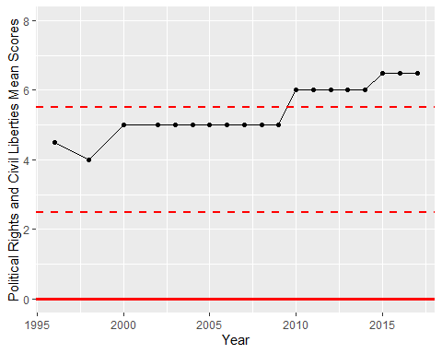

Freedom House Score Trend